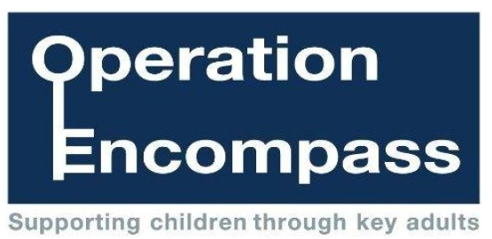

September 2021
Dear Parent/Carer
Our setting has been given the opportunity to take part in a project that will run in partnership between Cumbria County Council, the Office of the Police and Crime Commissioner and Cumbria Police.
The project, Operation Encompass, has been designed to provide early reporting to schools/nurseries/colleges of any domestic abuse incidents that occur outside of the setting’s hours and might have an impact on a child attending the setting the following day. The information will be shared on weekdays during school term time. When incidents occur over the weekend, the Operation Encompass Designated Officer will contact the relevant setting at the earliest opportunity to provide disclosure to the Designated Safeguarding Lead or their deputy within that setting.
A Designated Safeguarding Lead, or their deputy, has been trained to liaise with the Operation Encompass Designated Officer. Staff within an education/childcare setting will be able to use information that has been shared with them by Operation Encompass, in confidence, to ensure that the setting is able to make provision for possible difficulties experienced by children or their families. Information will be shared, on a need-to-know basis only, where it is identified that a child or young person was present, witnessed, or was involved in a domestic abuse incident.
Operation Encompass was introduced in Plymouth, Devon and Cornwall, in February 2011 and has proved to be very effective in providing appropriate support in a timely manner. If you would like to read more about the project in other areas of the country, this can be viewed online.
We are keen to offer the best possible responses for all children across Cumbria and believe that Operation Encompass is beneficial and supportive for all those involved.
Yours sincerely

